LOL morale and traning for educators & administrators K-12

A unique challenged learner turned educator; Tim Clue provides live and virtual experiences for educators throughout the US. His social emotional training highlights and demonstrates the social and neurological benefits related to best collaborative practices, and teambuilding, while providing practical tools for social emotional learning. And how to increase students buy-in for all subjects.

TIM IS A CERTIFIED DEVELOPMENT & TRAINING VENDOR FOR CHICAGO and TEXAS PUBLIC SCHOOLS.

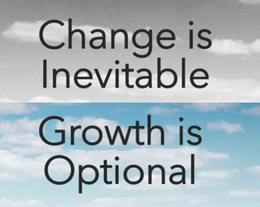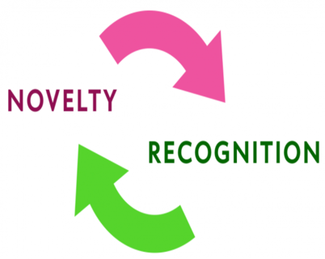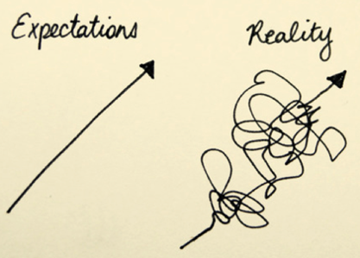
S
TOPICS
- SEL Tools not theory.
- Problem-Based Learning explored.
- The benefits and “how to” of classroom team building
- “Why kids need more content buy-in”
- Discomfort = Growth Modeling.
- How the rules of improv – can change a classroom, kids and schools
- Novelty recognition theory explained. Demonstrates the observer versus participant quotient

A Top Educational Speaker
Equity and access take a confident team and plenty of trust. That defines Tim Clue’s SEL & PBL (project-based learning) venture. The forces of the Educational Revolution are upon us, asking more from educational leaders than ever before. So, while you fight on the front lines, let Tim help build stronger, happier teachers and illuminate in real time a true-life example of project-based learning failing up, forwards and sideways. Experiential learning is the key to curating lifelong curious minds. We must hand over the keys and let students unlock doors to the paths and journeys they wish to light.
