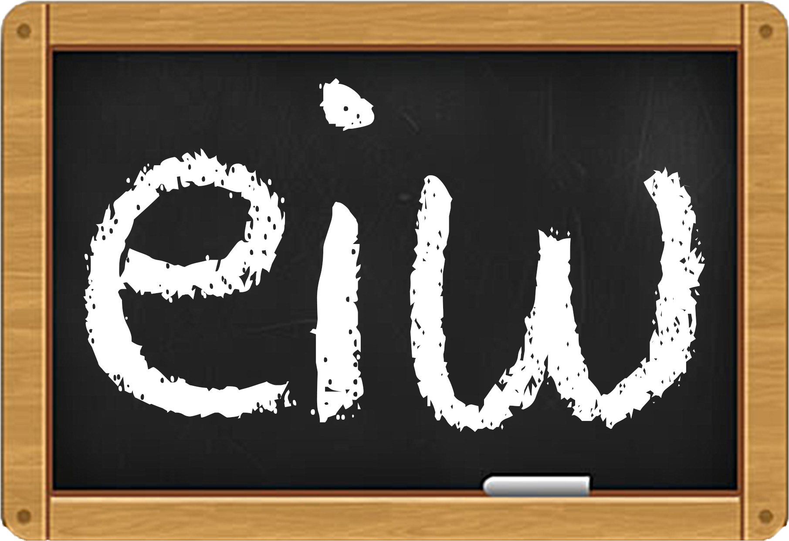
EducationalImprovWorks.org

Educational Improv WorksTM
Developing SEL and Language Arts through Public Speaking and Improvisational Practices

EIW instruction applies improvisation and public speaking skills to increase confidence, connection, personal literacy and best SEL (Social Emotional Learning) practices for untraditional learners from early education through high school.

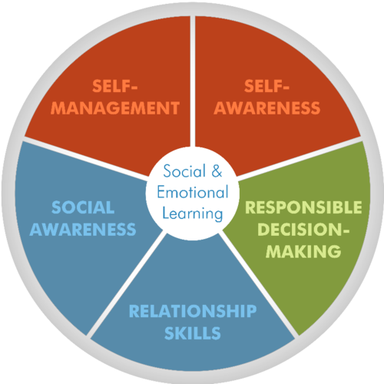
Introduction

Educational Improv Works (EIW)TM is not just our name, it's a statement of fact: Improv[isation] works remarkably well as an educational tool. It opens doors, minds, and sometimes even hearts that would otherwise stay locked. We've built our mission around that fact. EIW has adapted and synthesized decades of improv training and exercises into a single, unique regimen to help minds better communicate with themselves and others. This type of instruction is based on studies related to meta-cognition and is an SEL curriculum focused on collaborative small group communication.

Effects

EIW’s classes will open pathways, sustain curiosity and increase connections to help young minds better create, collaborate on, speak and organize their own content and stories. The group instruction will emphasize public speaking and listening, teach focus and critical thinking, and expand students’ verbal and non-verbal repertoire via the organization of thoughts, group storytelling, and team-building. Brainstorming and collaboration are an ongoing by-product.

Why Improv & Public Speaking?

This focus on connecting the disconnected and the improvement of a student’s SEL pallet—along with cementing basic but foundational communication skills—are the general attributes of the EIW program. Improv has been used to enhance the talents of CEO’s, managers and directors at Fortune 500 companies, sales teams and aspiring performers of all niches. The EIW program wishes to attract administrators and teachers who seek robust ways to increase engagement, connection, build community and activate long term dialogues and provide more communication skills for these underserved students.

It’s long been our contention that what improv and speech training have been providing for decades (group collaboration through play, organization and delivery a verbal scripts) is a well-honed, critical thinking superconductor that should be a natural part of every student’s schooling and curriculum, preparing students for communicating in the 21st century. Researchers now understand that language is more or less the first unofficial script a child explores. This program intensifies and expands a student’s script by fostering a more dynamic collaboration of self and voice through and with others.

EIW instruction teaches and improves communication skills connected to:

Vocabulary Collaboration Listening Team-building Brainstorming
Decision-Making Critical thinking systems Empathy Self-awareness Increased focus

… and expanding a students’ verbal and non-verbal repertoire by practicing skill sets small and large related to creative ideation and group storytelling.

Daniel Goleman, author of “Emotional Intelligence,” clarifies EIW’s desired impacts when he highlights that when “social, self-awareness and executive function IQ’s are increased, so too does motivation and the desire to succeed increase alongside.”

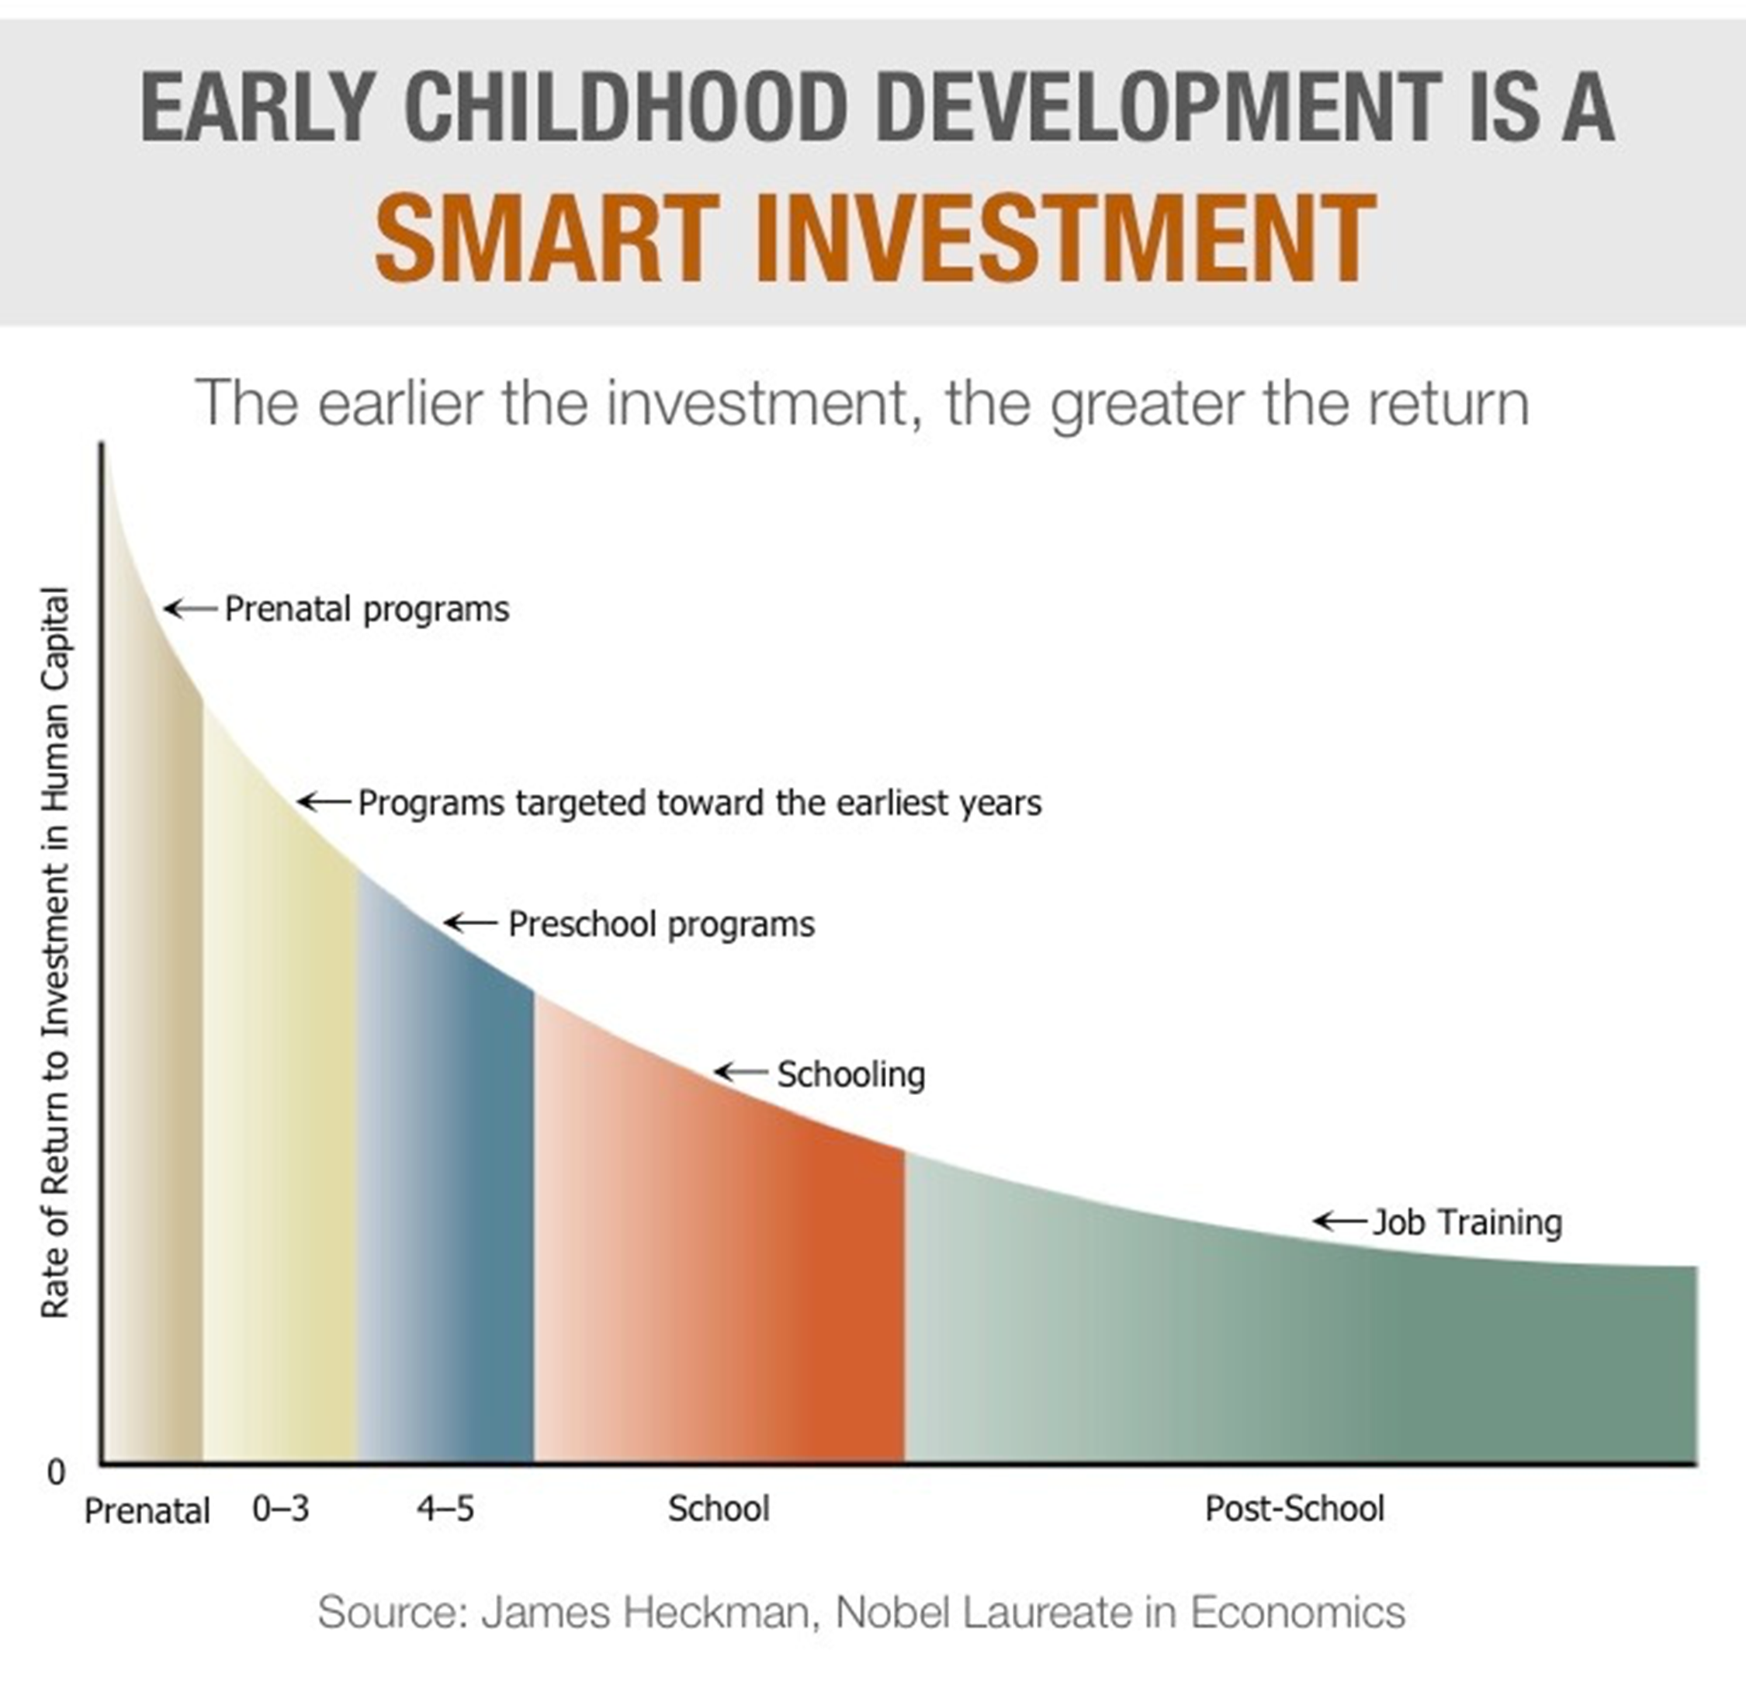

"Increasing the curiosity quotient is difficult to measure,
but not difficult to achieve.”
— Tim Clue, EIW Program Director
INFO@EducationalImprovWorks.com

Educational Improv WorksTM Mission Statement

The objective of Educational Improv Works (EIW) is to combine elements of improvisation exercises and public speaking to create a more dynamic Social Emotional Learning language arts curriculum, with the ultimate goal of providing cloud-based tools and short visual samples for every teacher in the United States who values the relationships between self-confidence, curiosity, language, reading and writing.

Group collaboration through play, organization and delivery of verbal scripts is a well-honed, critical thinking superconductor that should be a natural part of every student’s schooling, preparing them for communicating in the 21st century. EIW does not wish to create a school, but instead change the way all educational institutions teach connection, communication and language arts from First Grade through High School. We seek to rethink, reconstruct, reframe and rebuild language arts, with a special emphasis on disadvantaged urban centers and untraditional learners wherever they are underserved.
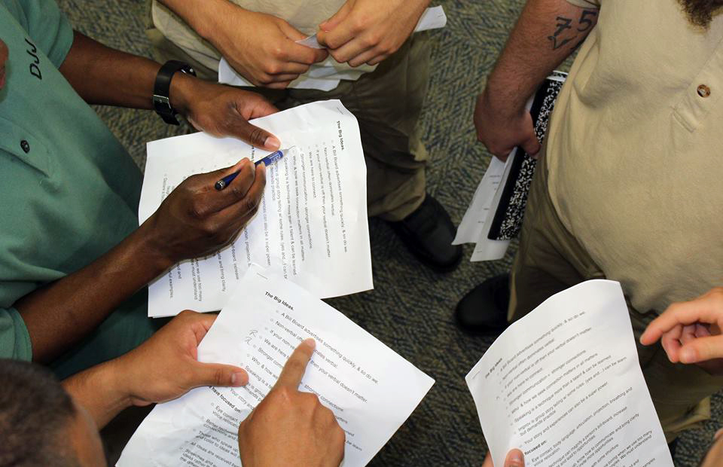
As our society moves to more visual ways to connect and communicate, so too will our language and communication skills need to move forward in order to keep pace. This next generation will be the most capably-connected but also in many ways the most disconnected in all of human history. EIW’s ambition is to offer early intervention in the shape of a robust language arts curriculum that will foster curious minds, expand vocabularies and confidence, connect the disconnected, and amplify students’ most undervalued resource: Creativity.

Educational Improv WorksTM
Administrators & Instructors
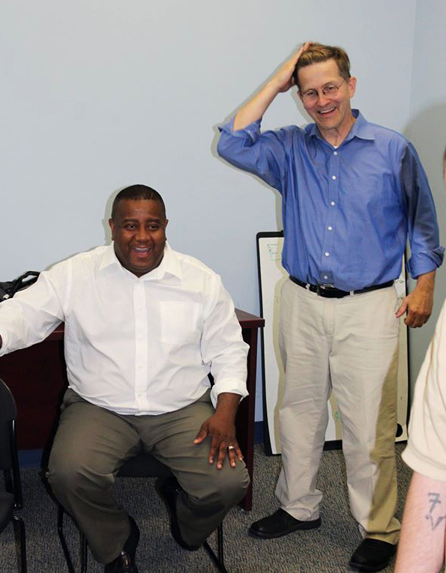
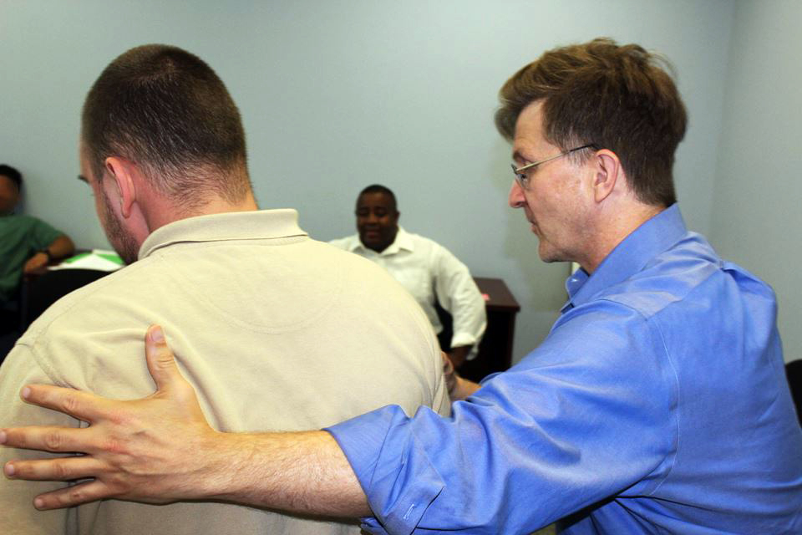

Tim Clue, Program Director

Tim brought to bear his experiences from years as an award-winning college-level educator, his training at Second City, and decades in stand-up comedy to synthesize his calling as a teacher and motivational speaker. With his Masters in Communication and Theater in hand, Tim advocates for and speaks around the country about breaking the hand raising dilemma and bringing classrooms online to match the pace, style and energy of a Google world while maintaining a grounded base in the spoken word. Passionate about building a program that combines his life’s work as an educator, writer, comic, and speaker, Tim seeks to inspire and share these abilities in all students of all ages. He continues to speak to educators around the country about the forces behind EIW and has appeared before such notables as former President George H.W. Bush and economist Paul Krugman. Tim’s passion for education are what brought EIW to fruition and will continue to lead it forward.

Educational Improv Works
Administrators & Instructors, cont’d

Spike Manton, Director of Development
Spike Manton learned the power of words and communication in college when he stumbled on to the Bradley University Speech Team and realized his true passion. Although he graduated Magna Cum Laude with a Business Degree and started out as a Procter & Gamble Sales Manager, Spike soon channeled his energies back into words and ideas, becoming a successful writer, radio personality and standup comedian with seven national television appearances. Parlaying his performing talent and business background into a career on the corporate circuit as a speaker and trainer, Spike sees EIW as the perfect opportunity to apply the knowledge gained from his uncommon professional experiences. A longtime advocate for children—working with organizations such as Prevent Child Abuse, Autism Speaks and The Gift of Hope, Spike envisions EIW as the vehicle to make a lasting impact on young people by changing and improving the way they learn to communicate. His ability to establish networks, forge relationships, and mobilize resources will guide the infrastructure of EIW.

Antoine McKay, Lead Instructor

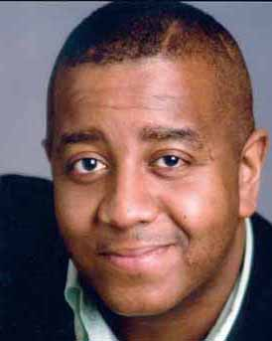
Antoine hails from Detroit, Michigan and is now making his home in Chicago with his wife and six (yes, six) children. Antoine has embraced and enjoyed education through the arts for nearly two decades. Honing his skills at Eastern Michigan University’s prestigious theatre arts program—studying under world famolus acting coach Uta Hagen—Antoine is a long time teacher, improvisor and actor (most recently as Bunkie Williams on Fox’s hit “Empire”). Antoine has offered classes in the performing arts with institutions such as The University of Notre Dame (South Bend), Northwestern University, The University of Chicago and Eastern Michigan University, as well as his own McKay Arts Management theatre company. Having seen first hand the power and effectiveness the EIW program can bring to any student in any environment, Antoine is excited to have the opportunity to participate in this ground breaking educational program.

Kathryn Lake, Managing Director

Kathryn resume begins and ends with a diverse and creative set of experiences and skillsets. A classically-trained violinist with a Bachelor’s degree from Boston University, Kathryn forsook performance as a career and began her professional life first as an orchestral Executive Director, honing her admin skills with budgeting, event planning, marketing and PR, and arranging European tours for 200 young musicians. From there it was full force into a career of radio announcing and marketing—including a stint as Chief of Staff for a U.S. Congressional campaign—followed by the formation of her own marketing and PR company, Self-Promotion, Inc., representing an exclusive roster of speakers and theatre companies. Drawn by EIW’s powerful message of the pursuit of knowledge of Self, effective communication and collaboration, Kathryn is excited to help promote this compelling educational program. Her organizational capabilities will help put EIW in front of educators and students eager to learn the power of Yes.

Dave Awl, Social Media Director

Dave is a writer, social media strategist, speaker, and trainer, as well as the founder of a small creative and digital marketing agency called Awlpoint. The author of the popular book “Facebook Me!” published by Peachpit Press, Dave has written extensively about social media and has appeared on radio and TV stations across the country discussing how to use Facebook effectively for both business and pleasure, and has been described by Time Out Chicago as "Facebook's Emily Post" because of his focus on good social media etiquette. Dave teaches social media marketing classes and workshops, and as a consultant, he helps organizations of all kinds successfully develop and maintain their social media presences. As a 10-year veteran of Chicago's popular Neo-Futurists theater company, Dave is also an accomplished actor and performer, as well as a published playwright and poet. Dave’s social media strategies will complement Kathryn’s marketing efforts to put EIW in front of educators and administrators across the US.

