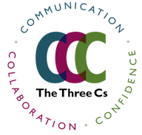

Objectives Goals and program explained

Developing SEL and Language Arts through Public Speaking and Improvisation
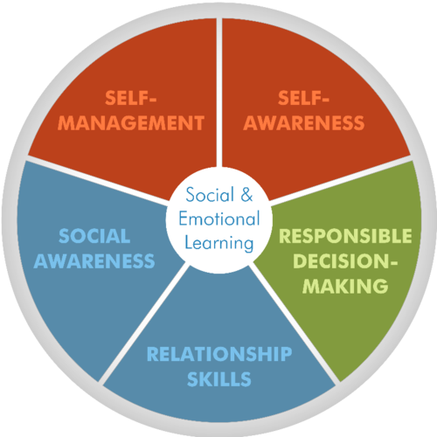

This next generation will be the most capably-connected but also in many ways the most disconnected in all of human history. This program asks teachers and administrations to rethink how we structure the exploration of language and the power of ideas. Teachers will learn first-hand how to use specific exercises to increase confidence and meaningful communication with a series of collaborative take-home strategies allowing them to consider how we implement meaningful change in the school day.

“Learning is better when we bring everyone along.”

Our program changes habits, culture and can address communication challenges in schools, providing teachers access to new pathways of building trust, connection and cooperation.

The objective of The 3 C’s is to combine elements of improvisation exercises and public speaking to create a more dynamic Social Emotional Learning language arts curriculum, with the ultimate goal of providing cloud-based tools and short visual samples for every teacher in the United States who values the relationships between reading, writing, self-confidence, curiosity, and language. Let’s understand how and why this tool could change classrooms

Group collaboration through play, organization and delivery of verbal scripts, is a well-honed, critical thinking superconductor that should be a natural part of every student’s schooling, preparing them for communicating in the 21st century. We seek to rethink, reconstruct, reframe language arts, with a special emphasis on disadvantaged urban centers and untraditional learners wherever they are underserved.

As our society moves to more visual ways to connect and communicate, so too will our language and communication skills need to move forward in order to keep pace. The 3 C’s ambition is to offer early intervention in the shape of a robust language arts curriculum that will foster curious minds, expand vocabularies and confidence, connect the disconnected, and amplify students’ most undervalued resource: Creativity.

THE TENETS OF IMPROV

- Yes, and...
- Listen in order to receive
- Build on what you receive
- You can’t be wrong
- Make your partner look brilliant
- Keep moving forward

Program & Curriculum

"Increasing the curiosity quotient is difficult to measure, but not difficult to achieve.”
— Tim Clue, The 3 C’s Program Director

An Improv Education curriculum is a paradigm shift in how to connect young minds to the power and function of language. This program applies improvisation and public speaking skills to increase the 3 C’s of confidence, connection, communication, challenges. The programs is designed with (Social Emotional Learning) best practices for untraditional learners from early education through high school to offer up a clear method to expand Soft skills soft skills matter which are latest battle cries from Educators to businesses to help build more capable minds for 21st century demands. Here’s a clarifying article entitled
Soft Skills NOW!

Our program is carved from decades of improv training and exercises into a single, unique regimen to help minds better communicate with themselves and others. My instruction is based on studies related to soft skills, meta-cognition, and a SEL curriculum focused on collaborative small group and individual communication. The key however is not to randomly teach children improv games, this is what other programs offer. Our appraoch utelize strees tested exercises in a stress tested formatt that can more carefully augment reading, writing and language programs long term.

The group instruction will emphasize public speaking and listening, teach focus and critical thinking, and expand students’ verbal and non-verbal repertoire via the organization of thoughts, group storytelling, and team-building. Brainstorming and collaboration are an ongoing by-product. We are certain that a well thoughts out strategic langauge based improv program will soon be apart of every child’s school day.

The 3 C’s improves communication skills connected to:

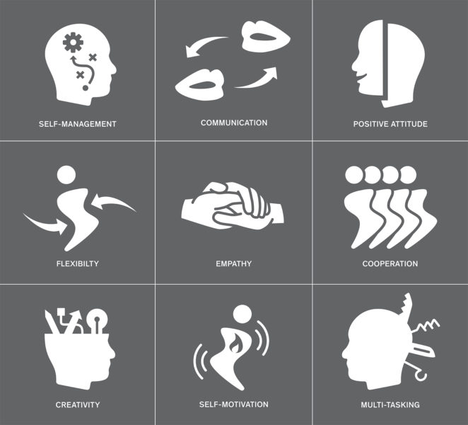

… and expands a students’ verbal and non-verbal repertoire by practicing skill sets small and large related to creative ideation and group storytelling.

Why Improv & Public Speaking?

Improv has been used to enhance the talents of CEO’s, managers and directors at Fortune 500 companies, sales teams and aspiring performers of all niches. The 3 C’s program wishes to attract administrators and teachers who seek robust ways to increase engagement, connection, build community and activate long term dialogues and provide more communication and writing skills for these underserved students.

It’s long been our contention that what improv and speech training have been providing for decades (group collaboration through play, organization and delivery a verbal scripts) is a well-honed, critical thinking superconductor that should be a natural part of every student’s schooling and curriculum, preparing students for communicating in the 21st century. Researchers now understand that language is more or less the first unofficial script a child explores. This program intensifies and expands a student’s script by fostering a more dynamic collaboration of self and voice through and with others.

Daniel Goleman, author of “Emotional Intelligence,” clarifies The 3 C’s desired impacts when he highlights that when “social, self-awareness and executive function IQ’s are increased, so too does motivation and the desire to succeed increase alongside.”

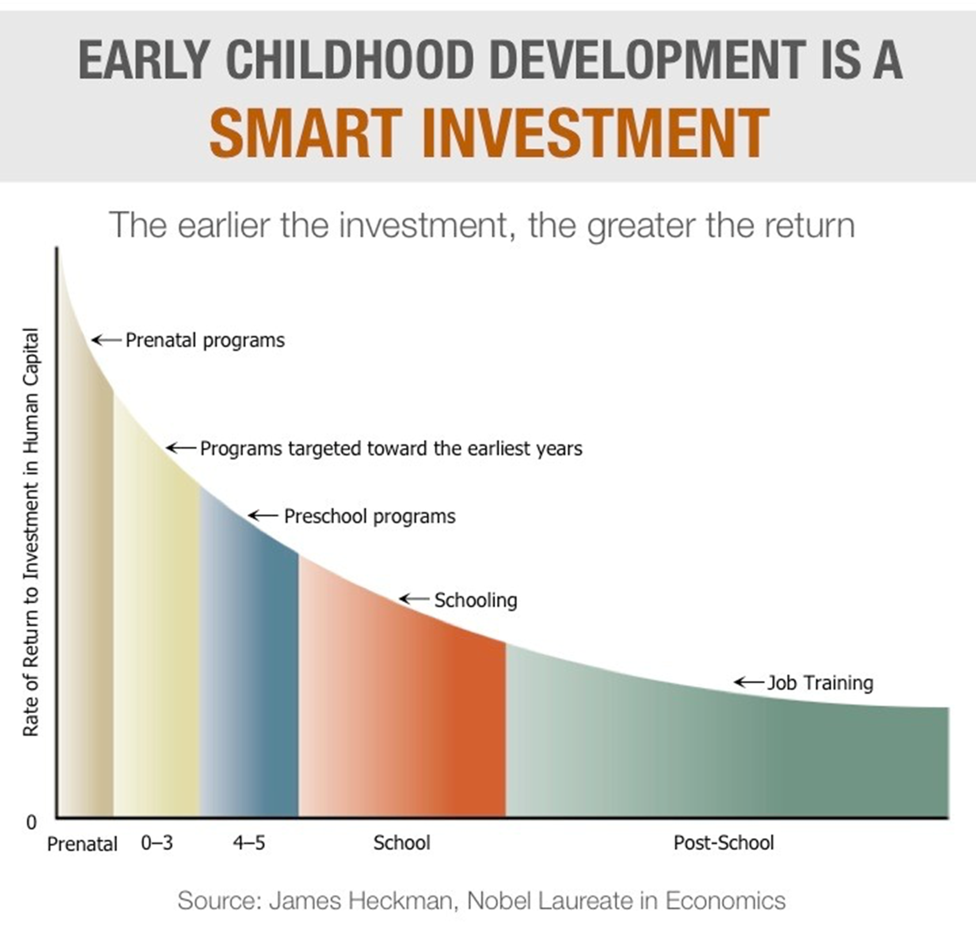

Our Three C’s program does not wish to create a school, but instead change the way all educational institutions teach connection, communication and language arts from First Grade through High School. We seek to rethink, reconstruct, reframe and rebuild language arts, with a special emphasis on disadvantaged urban centers and untraditional learners wherever they are under-served.

For more info. Please check out educational improv works This is another resourse we’ve added to tell our own story while promoting and explaining our goals and program’s approach.

Thank you

Tim Clue

